

Technical Documentation “ROTURE”

# PRODUCT DESCRIPTION

# The application allows you to create the illusion of subfolders, depending on the category hierarchy. Select a tag at the top level (for example, tag the date "06.2015") to move to the lower level (for example, the camera tag «Zenit-E»), and thus get access to the photographs, which were taken in June 2015 on the camera «Zenit-E». This greatly simplifies the organization and search of pictures on the disc.

# TECHNICAL REQUIREMENTS

ROTURE has to be a desktop application written on .net platform with usage of WPF, MVVM. Its purpose is to help photographer to organize photographs.

# EXAMPLES

On the form must be such parts: a hierarchical stack of the tag categories, the region with photo view, the region with a list of all imported photos.

When you select "Import" opens a dialog to select the folder from which the application will import photos.

When you click "Add Category" dialog box opens, in which the new category will be added.

If you press "Delete Category" opens a dialogue in which the category will be deleted.

When you drag a category up / down in a hierarchical stack changes the priority of this category relative to the others.

By clicking on the item with the name of the category unfolds a list of this category tags.

When you click on the tag in the application photos are filtered by the presence of this tag in the attribute, as well as filtered tags included in the category, which is lower in the hierarchy.

When you click "+" on the category item, text box appears to enter a new tag.

When you click "x" on the tag, one will be deleted and will be removed from all the photos .

Pressing the switch "Night Mode" is changing colors in application from the light theme to the dark one, and when pressed again, from dark to light.

When select the item of the pictures context menu "Tags", window opens in which you can tag photo to remove the tag from the photo, add a new tag to a category, and remove the tag from any category.

When select the pictures context menu item "Show folder", opens the folder containing the photo and selects the photo.

When you press the «Full Screen», current picture is opened on the full screen. Use the arrow keys on your keyboard or clicking on the right / left of the screen to navigate between pictures.

When you click on "Organize" opens a dialog in which the user selects the directory, which will consist photos arranged in folders. The application contains the standard tags "to delete," "processing."

By clicking on the "Delete" all pictures tagged "removal" are deleted.

By clicking on the "Share" opens a dialog, in which the user selects the social network (VK, FB, IG) to post current photo.

# MOCKUPS

1. Welcome page

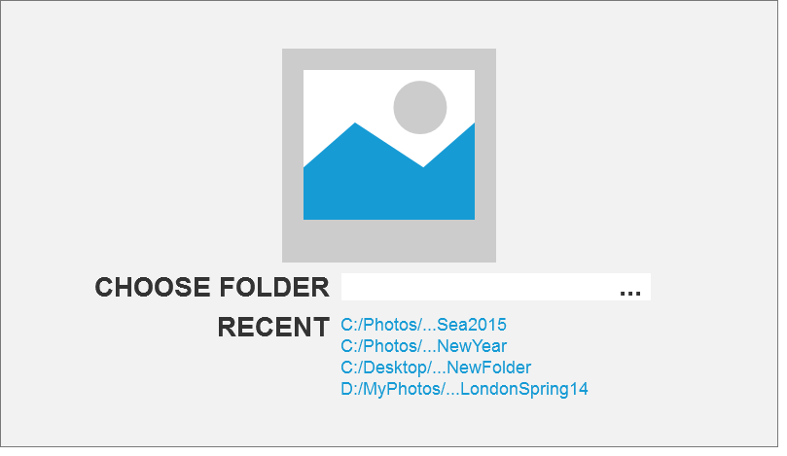

2. Main page

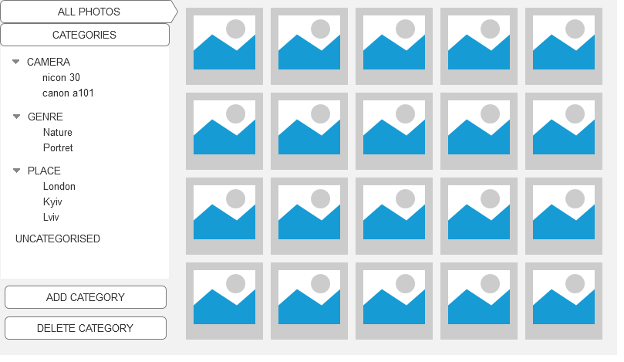

3. View page

